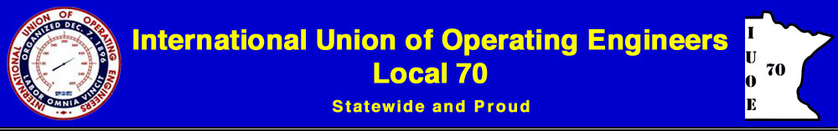

The Supreme Court issued a decision in Janus v. AFSCME Council 31 holding that agency fee agreements (sometimes referred to as fair share fees), such as the one contained in our Collective Bargaining Agreement, are not constitutional in the public sector. Effective June 27, 2018, IUOE Local 70 requested that your Employer immediately cease and desist deducting agency fees (fair share fees) from non–members such as yourself.

Key Reasons to Become an Active Union Member and Why Unions are Important:

- There is strength in numbers! Employers are more likely to listen to a strong union group during negotiations, and that can translate to higher wage settlements, increased benefits etc.

- You have a voice! As a member, you are involved in the creation of your Union Contract through proposal meetings and voting.

- Most union contracts provide greater protections than state and federal laws, and a union contract requires the Employer to bargain with Local 70 over wages, benefits, hours and working conditions.

- IUOE Local 70 provides many services including: staffing and maintaining an office, grieving contract violations, providing legal assistance, communicating with membership, negotiating contracts, providing training, and contributing to the International Union.

- There is a significant cost associated with providing the above services to over 5,000 people each year.

As a previous “fair-share” member do you have a choice as to whether or not to pay dues?

Yes, as of June 27, 2018 you have a choice. However, without financial contributions from ALL members, it will be difficult for IUOE Local 70 to continue in our current capacity. We ask that you consider how your job and life would change if the union was not available to handle grievances or negotiate wages, benefits, hours and working conditions?

Please consider signing the enclosed card to become a Member in Good Standing with IUOE Local 70. Signed cards may be mailed to our office in the enclosed postage-paid envelope, faxed to (651) 646-2858 or e-mailed to memberchanges@iuoe70.org.

If you have additional questions, please contact our office at 651-646-4566, or visit our website at www.iuoe70.org.

Jcb/opeiu#12

